**Bank Dataset Graphs:**

**Code:**

library(ggplot2)

df=read.csv("C:\\Users\\Atharva Dhande\\Documents\\Fall Sem 21-22\\Lab\\CSE3020\\BankDataset.csv")

ggplot(df) + geom_bar(aes(x=AgeGroup, y=NumberofLoans),stat="identity")

ggplot(df) + geom_bar(aes(x=AgeGroup, y=NumberofLoans),stat="identity") + geom_line(aes(x=AgeGroup, y=BadRate*2000,color="BadRate"),stat="identity",group = 1, size=1.3) + scale_colour_manual("", breaks = c("BadRate"), values = c("orange")) + scale_y_continuous(sec.axis = sec_axis(~ . / 2000, name = "BadRate"))

**OUTPUT:**

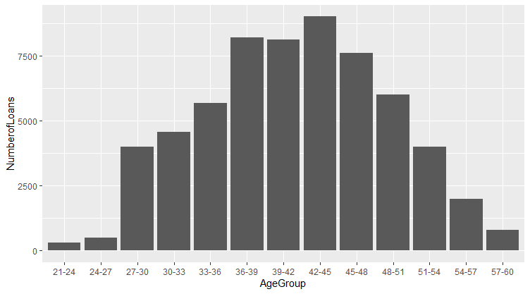

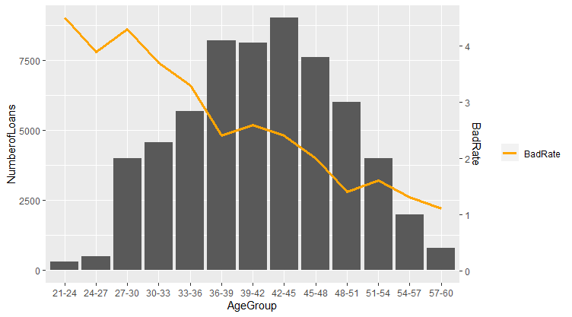

**Use the HR dataset to do the visual analytics with respect to the following points.**

1. Plot the number of employees belong to male and female category

2. Plot the number of employees recruited through various recruitment sources

3. Plot the no. of employees under each marital categories.

4. Plot the no. of employees under each marital categories with different colours

5. Plot the no. of employees under each marital categories in horizontal manner

6. Plot pie chart to represent employees belongs to various departments

7. Use histogram and density to plot employment status.

**CODE:**

df=read.csv("C:\\Users\\Atharva Dhande\\Documents\\Fall Sem 21-22\\Lab\\CSE3020\\HRDataset_v14.csv")

ggplot(df, aes(x=Sex)) + geom_bar()

ggplot(df, aes(x=RecruitmentSource)) + geom_bar()

ggplot(df, aes(x=MaritalDesc)) + geom_bar()

ggplot(df, aes(x=MaritalDesc, fill=MaritalDesc)) + geom_bar()

ggplot(df, aes(x=MaritalDesc)) + geom_bar() + coord_flip()

ggplot(df, aes(x = factor(""), fill = Department)) + geom_bar() + coord_polar(theta = "y") + scale_x_discrete("")

**OUTPUT:**

